**DAILY ONLINE ACTIVITIES SUMMARY**

|  |  |  |  |  |  |  |  |
| --- | --- | --- | --- | --- | --- | --- | --- |
| **Date:** | | **22/05/2020** | | | | | |
| **Name of the Faculty** | | **Ankitha Shetty** | | | | | |
| **No. of Students Allotted for monitoring** | | | | | **16** | | |
| **Progress** | | | | | **Good** | | |
| **Whether collected report from all the allotted students** | | | | | **9 submitted** | | |
| **Online Test Summary** | | | | | | | |
| **Subject** | **Operation Research** | | | | | | |
| **Semester** | **6** | | | **Duration** | | **1 hour** | |
| **No. of students Taken** | | | **107** | **Passing %** | | **95.3** | |
| **Certification Course Summary** | | | | | | | |
| **Course** | | 1. **Attended FDP on Cyber security by** Cambridge Institute of Technology 2. Attended FDP on **Artificial Intelligence by Brain o vision services** | | | | | |
| **Certificate Provider** | |  | | | **Duration** | | 1. **2days** 2. **5days** |
| **Coding Challenges** | | | | | | | |
| **Problem Statement:** | | | | | | | |
| **Status:** | | | | | | | |
| **Uploaded the report in Github** | | | | | **Yes** | | |
| **If yes Repository name** | | | | | <https://github.com/ankishetty91/ankitha-daily-report> | | |
| **Uploaded the report in slack** | | | | | **Yes** | | |

Online Test Details: (Attach the snapshot and briefly write the report for the same)

Certification Course Details: (Attach the snapshot and briefly write the report for the same)

Coding Challenges Details: (Attach the snapshot and briefly write the report for the same)

Online Test Details

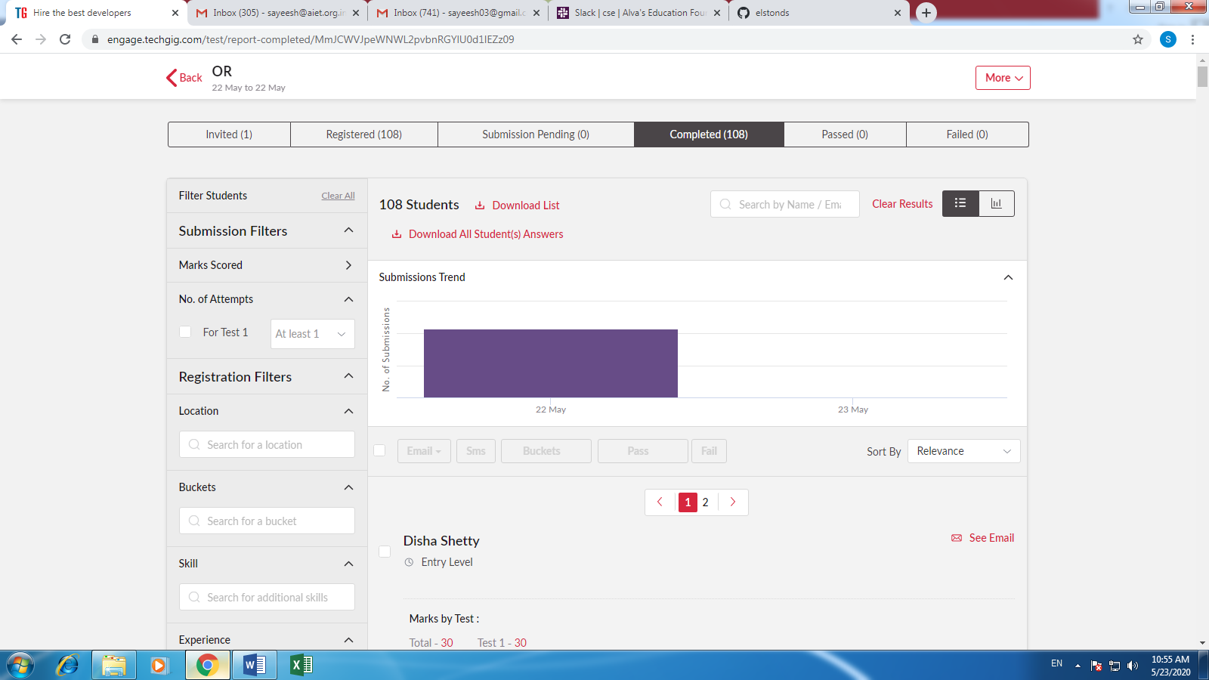

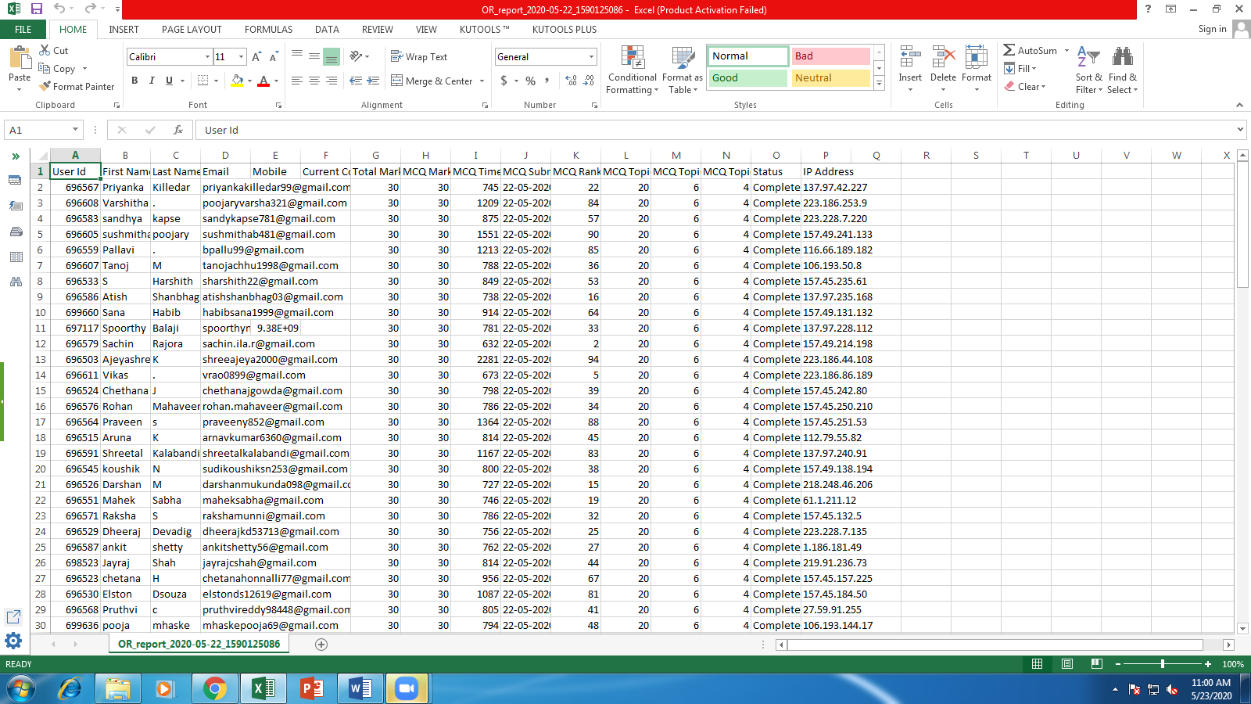

**Certification Course Summary**

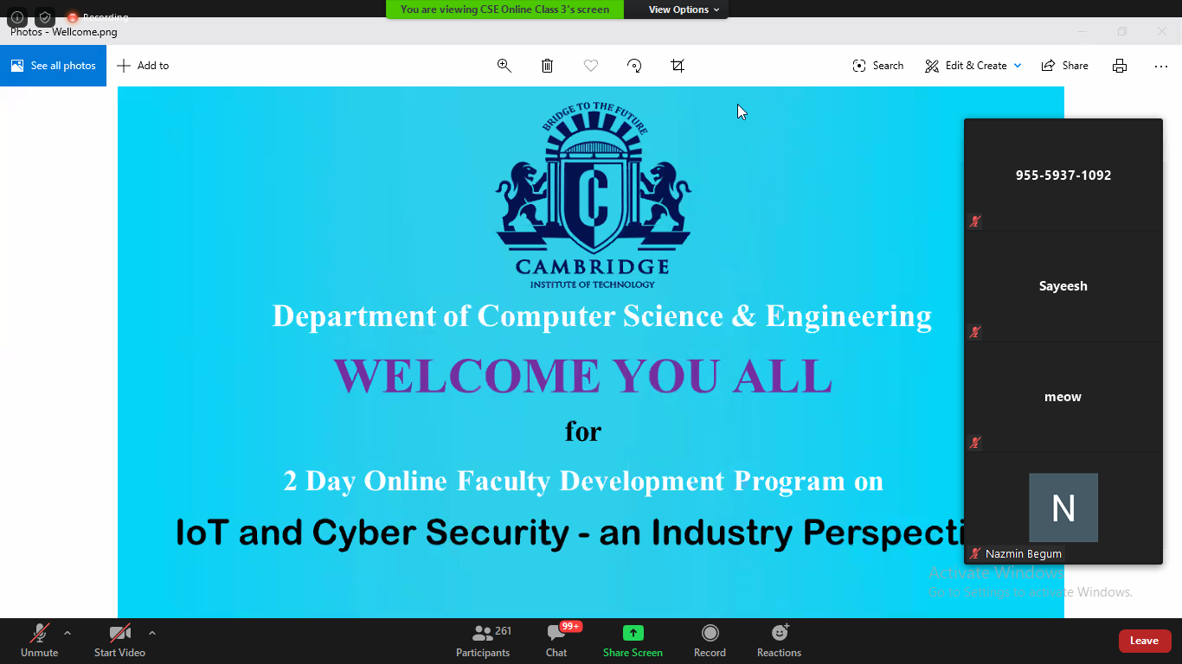

**Students Report:**

